You will need to structure your blocks in this level. To do so, remember:

To add blocks within the loop, divide it into two parts: left and right – the proportions will be 50% for each. If you place the next block to closer to the right part of the loop, it will be added inside:

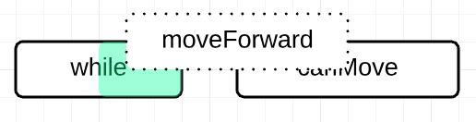

Inside the loop, which is shown by slightly moved to the right block:

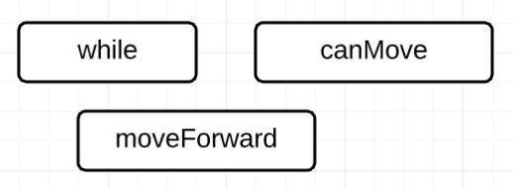

Otherwise, the new block will be separate from the loop:

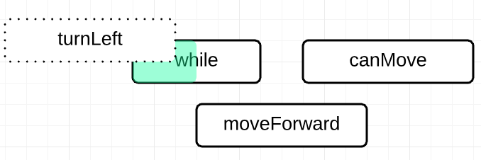

This has function “moveForward” inside the loop and “turnLeft” outside:

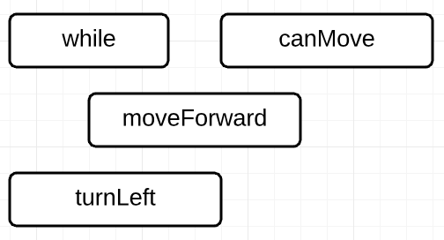

P.S. You can create another loop instead of “turnLeft” function.